Practical No.3

1. Simple Bar Diagram
Course <- c("BSc IT", "BSc CS", "BCA")
Students <- c(40, 35, 30)

barplot(Students,
names.arg = Course,
main = "Students by Course",
xlab = "Course",
ylab = "Students")
Output:
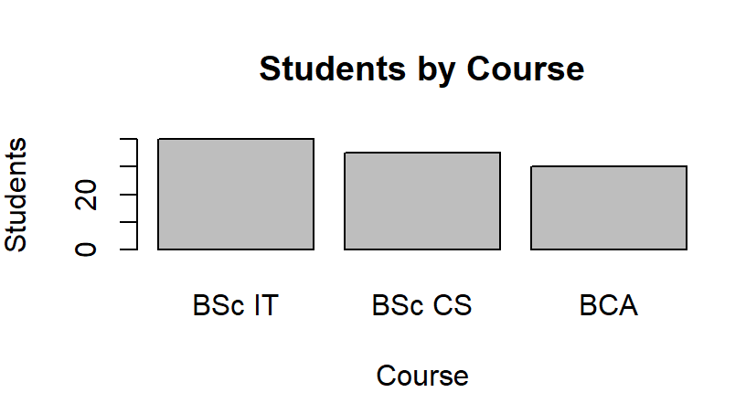

2. Subdivided Bar Diagram
data <- matrix(c(25, 15, 20, 15, 18, 12),
nrow = 2)

colnames(data) <- c("BSc IT", "BSc CS", "BCA")
rownames(data) <- c("Male", "Female")

barplot(data,
beside = FALSE,
main = "Students by Gender",
xlab = "Course",
ylab = "Students",
legend.text = TRUE)
beside = FALSE → bars are divided/stacked.
Output:
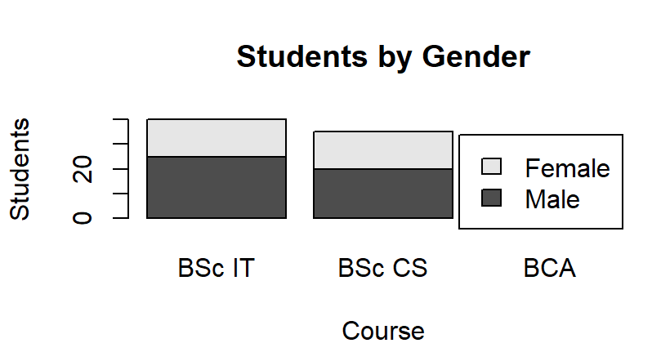
3. Multiple Bar Diagram
data <- matrix(c(25, 15, 20, 15, 18, 12),
nrow = 2)

colnames(data) <- c("BSc IT", "BSc CS", "BCA")
rownames(data) <- c("Male", "Female")

barplot(data,
beside = TRUE,
main = "Multiple Bar Diagram",
xlab = "Course",
ylab = "Students",
legend.text = TRUE)
beside = TRUE → bars appear side-by-side.
Output:
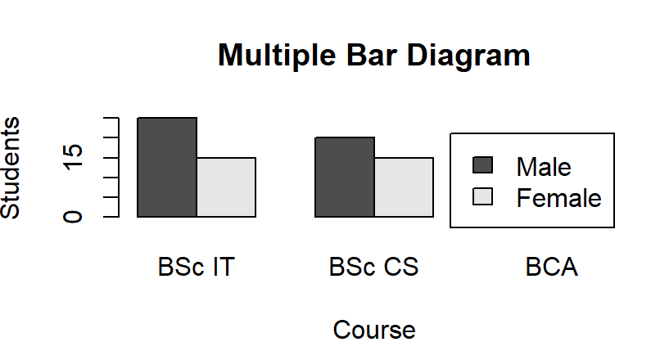

4. Pie Diagram
Students <- c(40, 35, 30)
Course <- c("BSc IT", "BSc CS", "BCA")

pie(Students,
labels = Course,
main = "Students by Course")
Output:
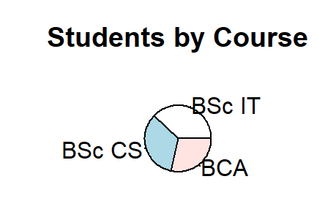

5. Box Plot
Marks <- c(45, 50, 55, 60, 65, 70, 72, 75, 80, 85, 90)

boxplot(Marks,
main = "Box Plot of Marks",
ylab = "Marks")
Output:
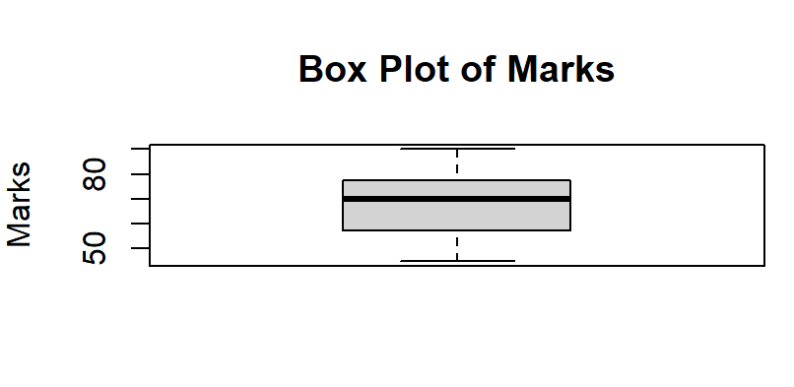

6. Histogram
Marks <- c(45, 50, 52, 55, 58, 60, 62,
65, 68, 70, 72, 75, 78, 80, 85, 90)

hist(Marks,
main = "Histogram of Marks",
xlab = "Marks",
ylab = "Frequency")
Output:

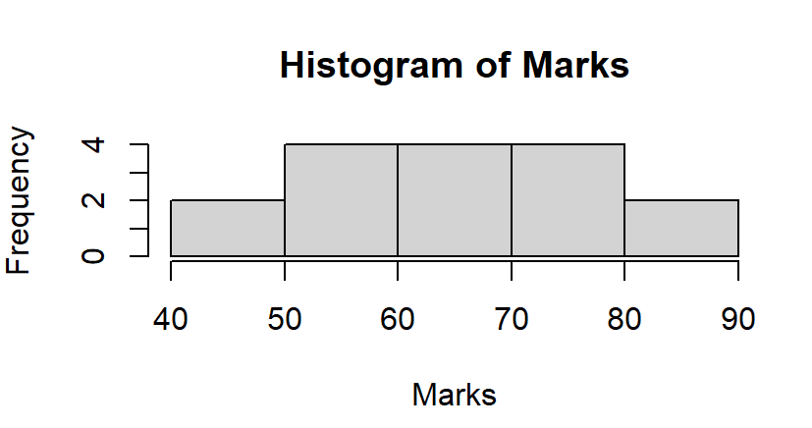

7. Frequency Polygon
Marks <- c(45, 50, 52, 55, 58, 60, 62,
65, 68, 70, 72, 75, 78, 80, 85, 90)

h <- hist(Marks, plot = FALSE)

plot(h$mids, h$counts,
type = "o",
main = "Frequency Polygon",
xlab = "Marks",
ylab = "Frequency")
Output:
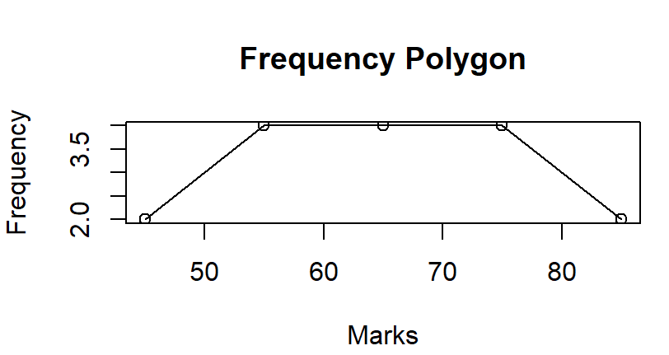

8. Scatter Plot using plot()
StudyHours <- c(1, 2, 3, 4, 5, 6, 7, 8)
Marks <- c(40, 45, 50, 58, 65, 70, 78, 85)

plot(StudyHours, Marks,
main = "Study Hours vs Marks",
xlab = "Study Hours",
ylab = "Marks",
pch = 19)
Output:
